**Practical No. 3**

**Aim :- Using linux terminal or window cmd execute following networking commands and note the output :- ping, traceroute, netstat, arp, ipconfig**

1. **arp –a :**

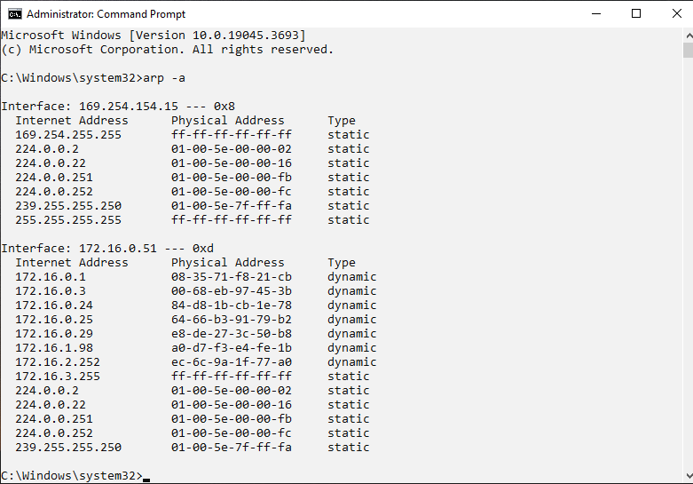

1. **ipconfig :**

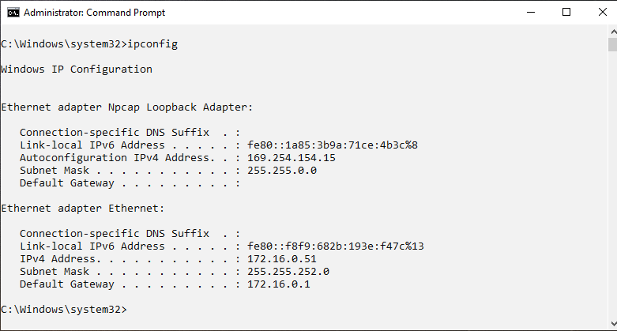

1. **ping :**

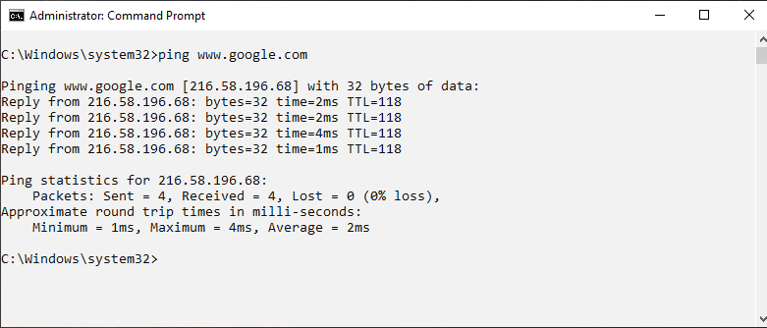

1. **tracert :**

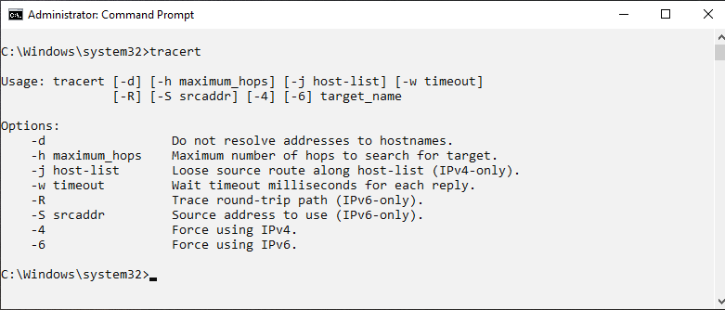

1. **hostname :**

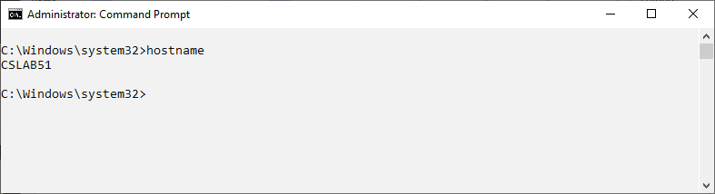

1. **netstat :**

